Justin Marucci

Assignment 6.2

04/20/2025

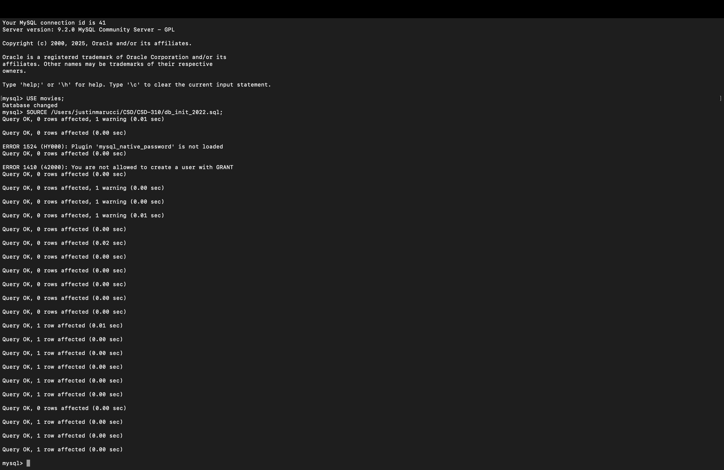Script Execution Output

I could not figure out how to get a stable connection. I believe I am missing something small but I cannot figure it out.

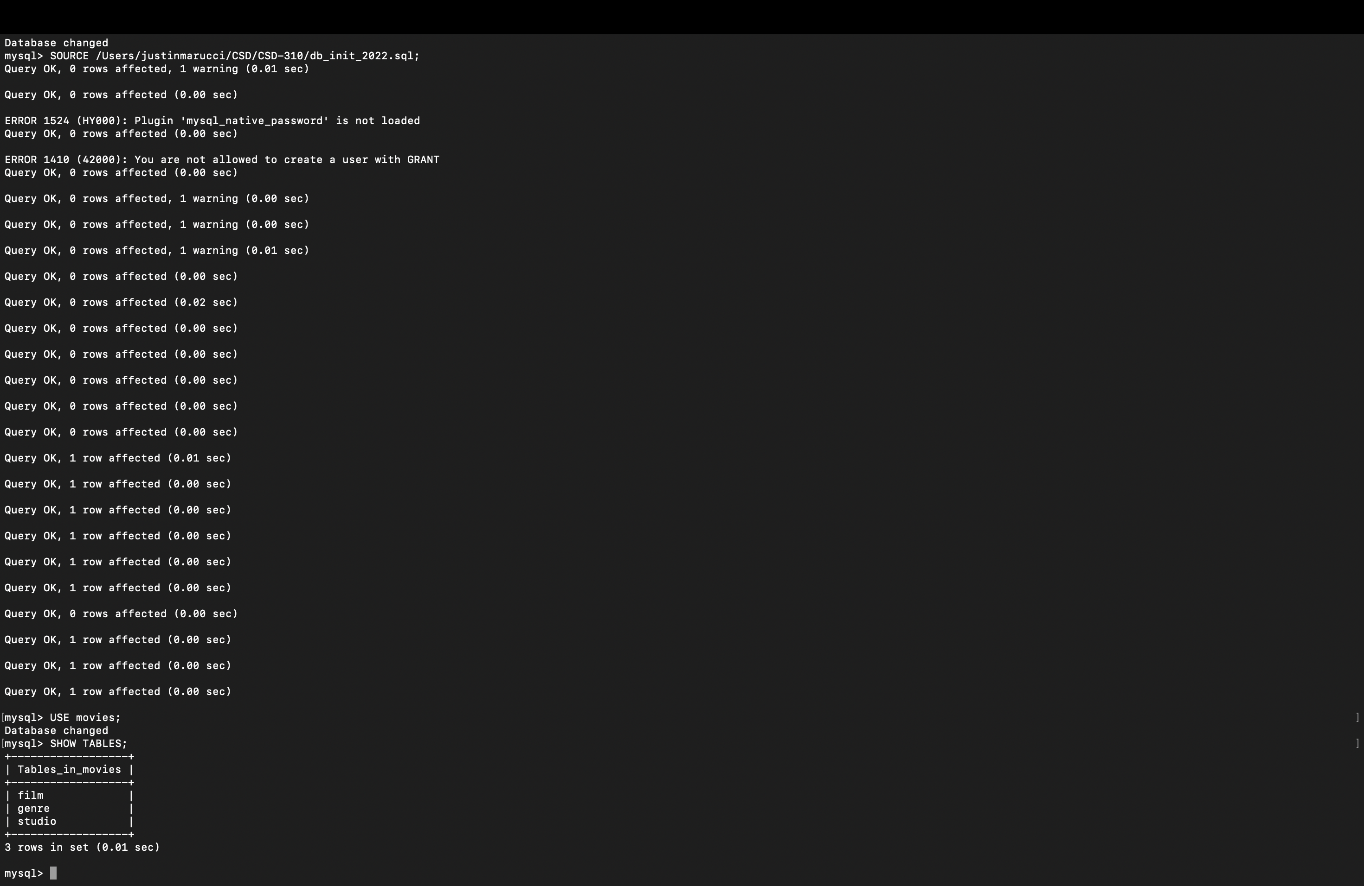

Show Tables Output

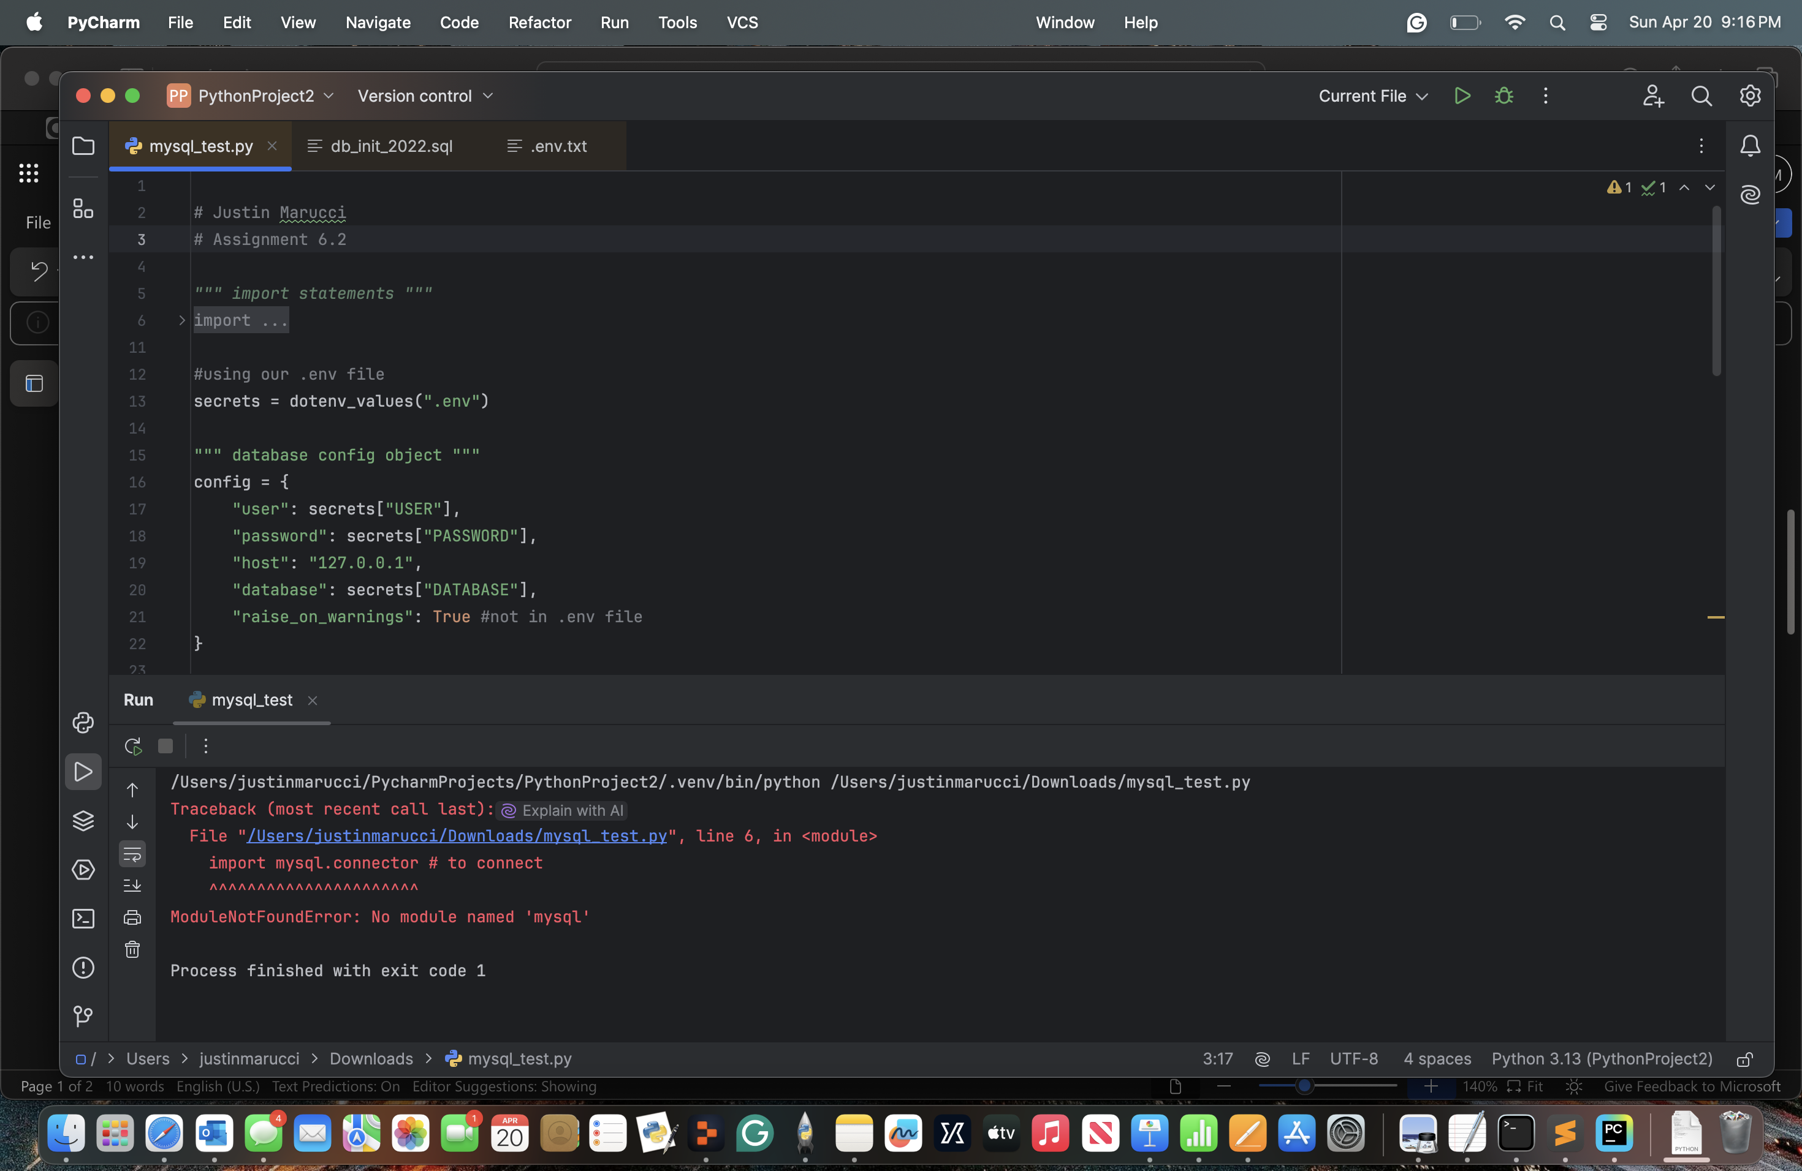I could not figure out how to get a stable connection. I believe I am missing something small, but I cannot figure it out. I usually use Replit as an IDE, but then I read it cannot stabilize a connection. Do I need to edit the .env file? Please see the below.

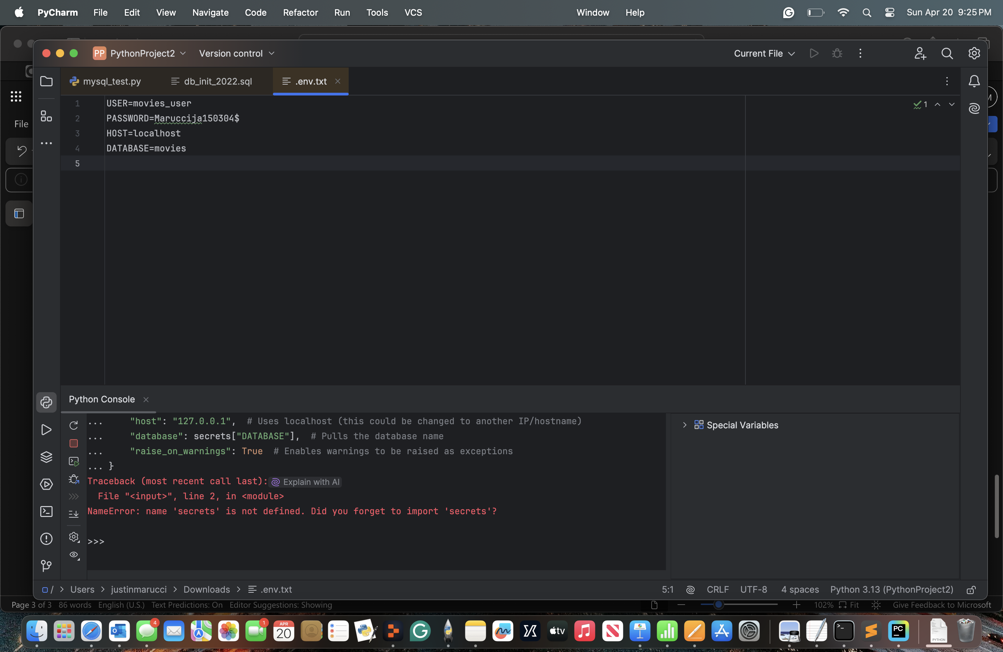

<https://github.com/Marucci212/CSD-310>